"""Part 1:

Write a Python program to find the addition and subtraction of two numbers.

Ask the user to input two numbers (num1 and num2). Given those two numbers, add them together to find the output.

Also, subtract the two numbers to find the output.

"""

def get_numbers(message):

while True:

try:

num1 = float(input(message+"Enter the first number: "))

num2 = float(input(message+"Enter the second number: "))

return num1, num2 # return the numbers when valid input is received

except ValueError:

print("Invalid input. Please enter numbers only")

# Perform adding and substraction

def add_substr():

message="Addition and Division. "

num1, num2 = get_numbers(message) # call get_numbers() once and unpack the returned tuple

sum = num1 + num2

difference = num1 - num2

# Print results

print("Sum of "+str(num1)+" and "+str(num2)+" is:", sum)

print("Difference of "+str(num1)+" and "+str(num2)+" is:", difference)

"""Part 2:

Write a Python program to find the multiplication and division of two numbers.

Ask the user to input two numbers (num1 and num2).

Given those two numbers, multiply them together to find the output. Also, divide num1/num2 to find the output."""

# Perform multiplication and division

def multi_div():

message="Multiplication and Division. "

while True:

num1, num2 = get_numbers(message) # call get_numbers() once and unpack the returned tuple

multi= round(num1 *num2, 2)

# Handle division by zero error

if num2 != 0:

div = round(num1 / num2, 2)

print("Multiplication of "+str(num1)+" and "+str(num2)+" results:", multi)

print("Division of "+str(num1)+" and "+str(num2)+" results:", div)

break

else:

print("Cannot divide by zero. Enter a non-zero for second number. Try again.")

continue

add_substr()

multi_div()

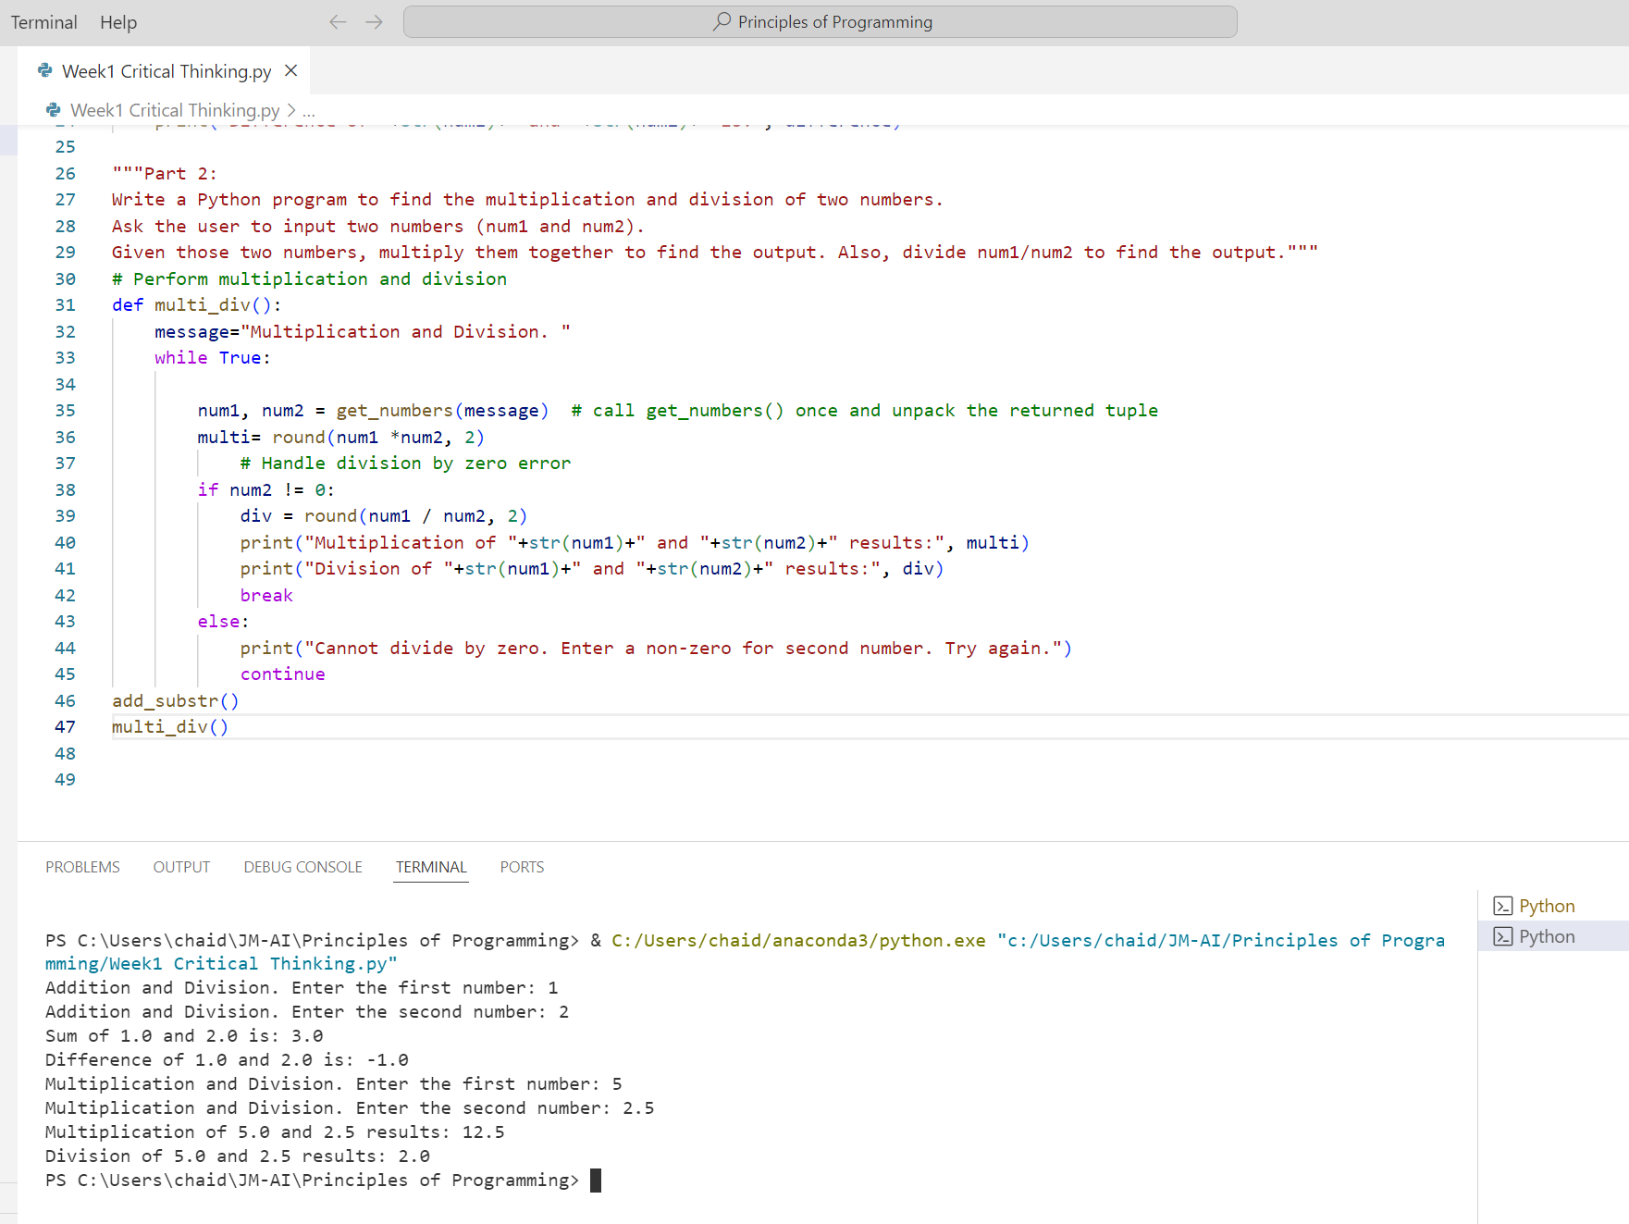

Github path:

<https://github.com/mengjin2211/JM-AI/tree/6288cad4e96db00406cfd50cfb3267cfaa70ded6/Principles%20of%20Programming>

